Using CH4 high% 191C – Low conc are off by 8.8% (conc=1%) and 3.3% (conc=2%) and 1.6% (conc=3%)
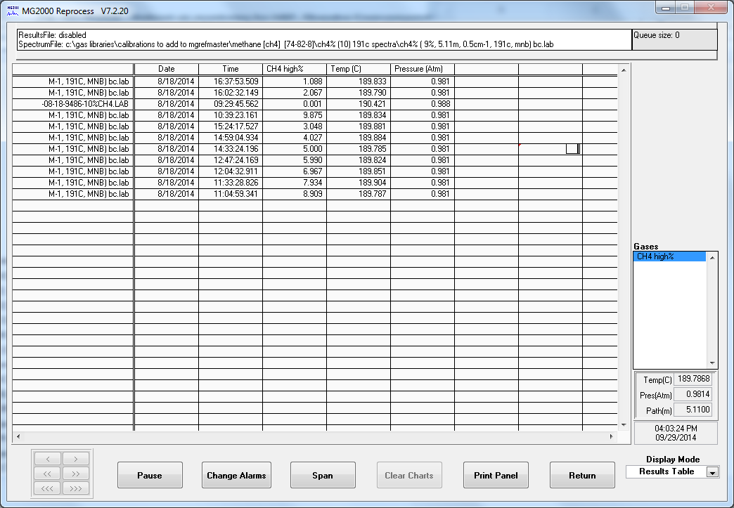
Using CH4 (20000) 191C – Low conc are off by 8.2% (conc=1%) and 3.15% (conc=2%)
